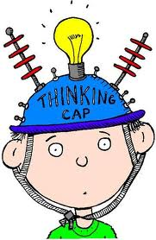
Thinking Stems
Here are some sentence starters to help you begin your reading responses:
- Today in my reading I visualized…
- In my reading I’m noticing that…
- After reading today I predict that…
- Today I made an inference. I figured out that…
- I’m beginning to wonder…
- Today in my reading I was feeling _______ because…
- One thing that confused me today was…
- Today in my reading I made a connection to my life. I was reminded of…
- I was completely surprised when…
- Today my feelings changed when…
- I learned some important background information today.
- The protagonist in my book…
- The conflict in this story…
- The mood in the story took a turn today.
- I wanted to learn more about ___________, so I went on a Knowledge Quest. I learned…
- Today I finished my book. I think the author’s message to me was…

