Name ____________________________________________ Date ______________________
Study Guide
Egypt – Summative Test

Know the definitions for each of the following words.
- cataracts -
- hieroglyphics -
- pharaoh -
- delta -
- dynasty -
- pyramid -
- papyrus -
- theocracy -
- embalming -

Be able to label a map of Ancient Egypt
Nile River
Lower Egypt
Western Desert
Arabian Desert
Red Sea
Upper Egypt
Nile Delta
Eastern Desert
Mediterranean Sea
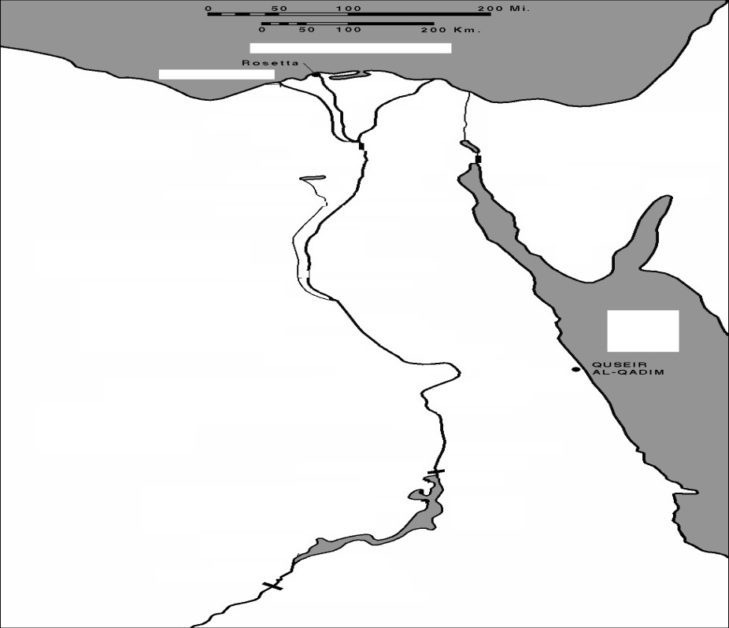

Be able to label the social class pyramid of Ancient Egypt

Describe some of Ancient Egypt’s most important contributions in the areas of:

Medicine:

Writing:

Architecture & Art:

Astronomy:

For the essay part of the test, you will be asked to DISCUSS the following in DETAIL:
- the role a pharaoh played in a theocracy

- the purpose of a pyramid

- the Egyptians belief in the afterlife

- the benefits of the Nile River to the Egyptians.

